Exception Handling

What is Exception Handling:
- It is the process of how our application deals with unexpected runtime errors without crashing
- Example errors:
  - NoMethodError
  - ActiveRecord::RecordNotFound
  - ZeroDivisionError
  - PG::UniqueViolation
- Without handling:
user = User.find(params[:id])
With handling:
Begin
user = User.find(params[:id])
rescue ActiveRecord::RecordNotFound
redirect_to users_path, alert: "User not found"
end

Purpose of Exception Handling:
- Prevent app crashes
- Show user-friendly messages
- Logs errors for debugging
- Maintain application stability
- Separate business logic from error recovery logic
- Protect sensitive information (don’t expose stack traces)

Core Ruby exception handling :
- Basic Syntax:
Begin
# risky code
rescue => e
# handle error
end
- Always rescue specific errors, never rescue all errors blindly in production
- There can be multiple rescue blocks:
Begin
risky_operation
rescue ActiveRecord::RecordNotFound
puts "Record missing"
rescue StandardError
puts "Something went wrong"
end
- else Block:
Runs if no exception occurred:
Begin
puts "Safe"
rescue
puts "Error"
else
puts "No error occurred"
end
- ensure Block:
Always runs (like finally in any other language):
begin
risky_operation
rescue
puts "Error"
ensure
puts "Cleanup always happens"
end
Used for:
  - Closing files
  - Releasing connections
  - Cleanup tasks

The Exception Hierarchy:
- All ruby errors inherit from:
  - Exception
└── StandardError
├-- NoMethodError
├-- ArgumentError
├-- RuntimeError
└── ...
- Rails usually raises errors under StandardError
- When we do rescue => e, it rescues StandardError by default – NOT System-Level errors.

Raising Exceptions:
- We can raise errors manually
Eg,
raise “Something went wrong”
- Or custom:
Eg,
raise ArgumentError, "Invalid input"

Custom Exceptions:
- To create our own error:
class PaymentFailed < StandardError; end
def process_payment
raise PaymentFailed, "Card declined"
end
rescue PaymentFailed => e
puts e.message
end
- Used heavily in service objects in Rails

Controller – Level Exception Handling in Rails :
- Rails provides:
rescue_from
- Eg,
  - class ApplicationController < ActionController::Base
rescue_from ActiveRecord::RecordNotFound, with: :not_found
def not_found
render file: Rails.root.join("public/404.html"), status: :not_found
end
end
- Now all controllers inherit this

Common Rails Exceptions:
- ActiveRecord::RecordNotFound
- ActiveRecord::RecordInvalid
- ActiveRecord::RecordNotUnique
- ActionController::ParameterMissing

Save vs Save! :
- user.save -> returns false if failed
- user.save! -> raises exception
- When to use save!:
  - Want a transaction rollback
  - Want failure to stop execution
- When to use save:
  - Validation failure is normal flow

Exception Handling with Transactions:
- Rails transaction auto – rollback if exception occurs.
- Eg,
  - ActiveRecord::Base.transaction do
user.save!
profile.save!
end

Global Exception Handling (Production Level):
- Rails production config:
  - config.consider_all_requests_local = false
- Rails automatically renders :
  - 404 page
  - 500 page
- We can override that via
  - config.exceptions_app = self.routes
- Then define routs for error pages

When not to use Exception:
- Exceptions are not suited for normal flow’
- Eg,
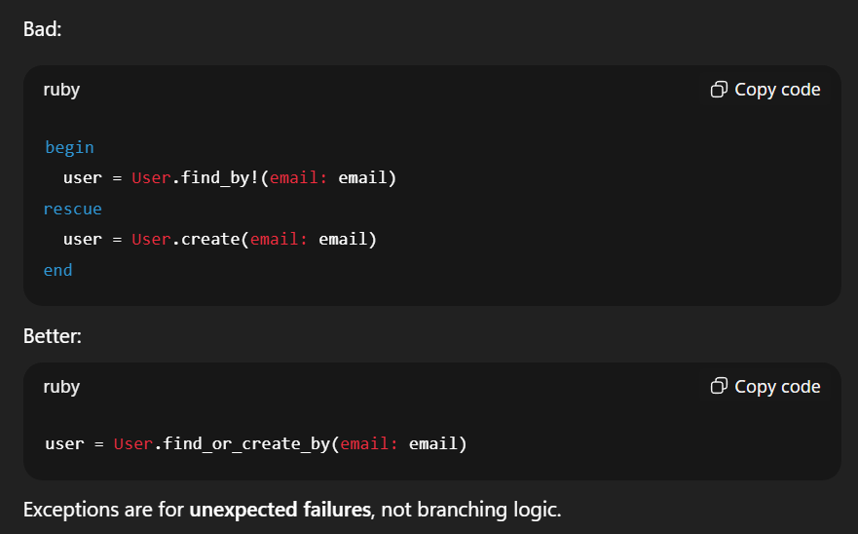

Exceptions vs Validations:
- Validation failure is not an exception unless we use save!
- Validation -> Business rule failure
- Exception -> System/runtime failure

Advanced Pattern: Service Object + Custom Errors:
- Professional Rails pattern:
class PaymentService
class PaymentFailed < StandardError; end
def call
raise PaymentFailed, "Insufficient funds"
end
end
Controller:
rescue_from PaymentService::PaymentFailed do |e|
redirect_to checkout_path, alert: e.message
end

Retry Logic:
- Used for:
  - API failures
  - Networks issues
- Eg,
retry_count ||= 0
begin
external_api_call
rescue Timeout::Error
retry_count += 1
retry if retry_count < 3
end

Performance Consideration:
- Exceptions are expensive
Don’t use them inside loops
- We can use condition checks instead inside a loop

